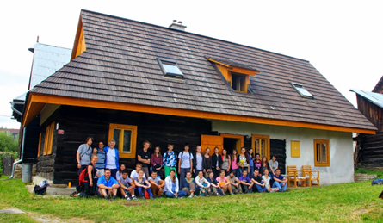

UNIQUE EDUCATIONAL VACATION RENTAL OFFERED IN SLOVAKIA
October 2015
By Michal Kravčík

Dear friends of the environment, supporters of justice and protectors of human rights, I have a
message for you. Twenty-two years ago, I along with friends established a conservation organization known as People & Water (Ludia a voda) with the intent of protecting water and communities endangered by large water dams and reservoirs. We promote ecologically friendly and socially just solutions in water management in order to maintain and improve the long term sustainable quality of life and with it spread the development of democracy in post-communist Slovakia.
The NGO People & Water is a small organization with low funding yet we have continuously contributed to the development of democracy and integration into the European Union. That is why we are calling out to people across the world, to those who value freedom, independence and a culture of democracy to help us support People & Water. We are offering a unique opportunity for rental of our community center for a vacation combined with educational and recreational activities.
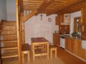
The community centre is surrounded by the beautiful natural settings of Upper Torysa, the area that has been successfully fighting for over 20 years against the construction of a large water reservoir by the state water company, which would permanently affect five villages and its inhabitants' way of life. The community centre is actually a 114-year old wooden home that is a registered natural heritage landmark with 4 rooms and 7 beds and all amenities to make ones stay comfortable. Over the past 15 years, we have restored this landmark to reflect its heritage while simultaneously providing modern comforts. Local materials were used for all renovations.
If friends and other groups are interested in a getaway in a quiet rural mountainous region within the vicinity of the historical town of Levoca (15km), two national parks (Slovak Paradise – 31km and High Tatras – 52km) then we offer an opportunity to reserve the rental of the cottage with an upfront payment, and then reserve your stay based on your schedule. The rental of the entire community centre is 100 euros for 1 day, 500 euros for 1 week, 900 euros for two weeks and 1500 euros for one month. With your support, we will be able to save People & Water from threatened liquidation while simultaneously preserving the property in order to continue with our local development activities for the inhabitants of the Upper Torysa community. Contact me, Michal, at kravcik@ludiaavoda.sk.

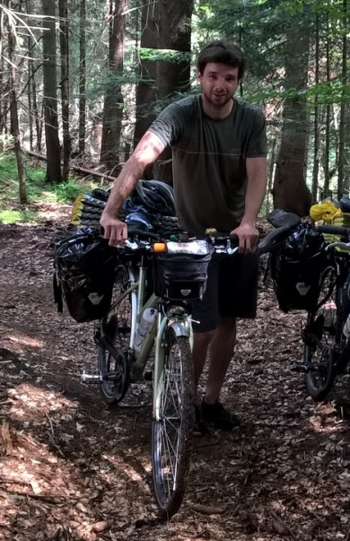
BICYCLE TOURS IN SLOVAKIA FOR THE ECO-CYCLIST

Are you a cyclist looking for an affordable biking adventure? Combine your stay at the Community Centre with bicycle touring arranged by Peter Bujnak, avid cyclist and tour guide to Slovakia's beautiful cycling paths and roads, as well as extensive knowledge of Michal Kravčík's restoration projects. Peter is fluent in English. He will offer customized tour packages for road and mountain biking beginning in May 2016, for everyone from casual riders to seasoned racers. Contact Peter at pbujnak82@gmail.com for more information.

MVO Ľudia a voda, Čermeľská cesta 24, 040 01 Košice, www.ludiaavoda.sk, e-mail: ludiaavoda@ludiaavoda.sk, tel./fax: +421(55)7998806, IČO: 31302921, DIČ: 2020928404,
IBAN: SK29 3100 0000 0043 5007 5633, SWIFT: LUBASKBX, Sberbank Slovensko, a.s.,

Founded in August 1993, NGO People and Water is the partner for local self-administrations,
entrepreneurs, other NGO-s, schools and research institutions with respect to sustainable recovery of
the environment, especially in Carpathian Euro region, but also elsewhere (in partnership with
organizations from Ukraine, Poland, Hungary, Bulgaria, Rumania). The NGO keeps and cultivates
existing partnership relations focusing on the development of countryside communities in pilot
regions across Eastern Slovakia (watersheds of Torysa, Hornád, Svinka, Oľšava). The NGO assists
municipalities and regions with the design of programs for the integrated protection of water. NGO
activities are devoted to education of youth and adults in Eastern Slovakia; implementation of pilot
projects; awareness-raising and supporting legislature changes related to utilization and protection
of water resources, anti-flood protection, water scarcity, enhancement of biodiversity and adaptation
to negative consequences of climate change. We organize information campaigns focused on the
utilization of eco-technologies with respect to water sources, treating waste water, alternative sources
of energy, ecological life-styles, anti-flood prevention and the like. We assist networking in
underdeveloped regions. We support conditions favourable for skills development, as well as the
establishment of centers of innovation, technology and information. We create space for the
establishment of community foundations, associations, associations based on multi-sectoral approach
(public administration, entrepreneurs, experts, civil society). Furthermore, NGO People and Water
co-operates with international institutions for the implementation of water protection programs
based on principles of a New Water Culture. Our publication “Water for theRecovery of the Climate – A New Water Paradigm” was introduced to the European Commission and was taken into account in preparation of EC White Paper on Drought and Flood Prevention.Currently People & Water continue to provide guidance on a variety of local projects dealing with landscape restoration with the intent of protecting rainwater.

